Horton Lodge School
“Working Hand in Hand to Achieve Potential”
All About Kiplings
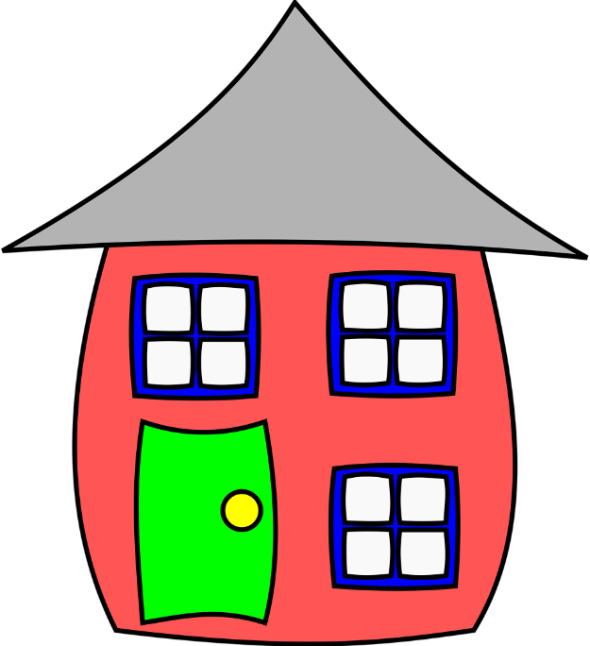
Children's Statement of Purpose
Meeting National Minimum Standards September 2022
September 2025

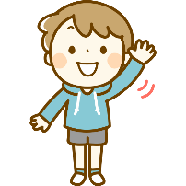
“Hello and Welcome to Kiplings”
Introduction
Kiplings is the residential part of our school. We can stay for tea and clubs and sometimes a sleepover.
At Kiplings we explore lots of new activities and learn how to do things differently.
We work on our targets from class and have new ones from Kiplings; we practice these during lots of different activities and at different times.
We practice our communication using many different ways to show how we feel, to make our choices heard and to make changes that are important to us. We use our PODD books, symbols, objects of reference, electronic devices, signing, facial expressions, giggles and sometimes cry so that grownups know how to help us.
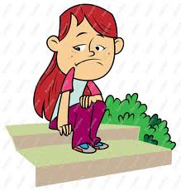
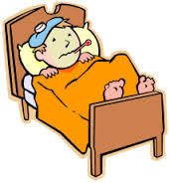
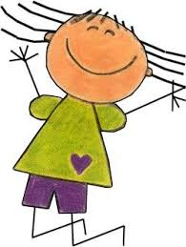


We explore topics and enjoy activities, listening, reading, using numbers, counting, sorting and organising and we have lots of creative messy fun. We all have a Key worker who looks after our files and is there to talk to if we need someone.




“We engage and explore”
We work on our targets from class and have new ones from Kiplings;

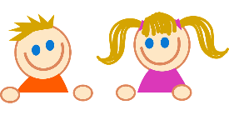
Communication
Practicing and finding ways to let others know what we need.

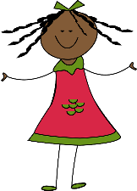
Independence
Learning new skills that we can do alone or with a little help.

Socialisation
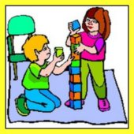
Being with our friends and making new friends, and having lots of fun.

Positive Behaviour

We learn and practice ways of getting help when we need it, listening, sharing, waiting and being kind to ourselves and others.

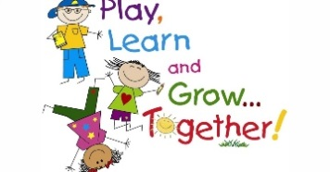
Healthy Lifestyle
Exploring and joining in with new activities, and trying new tastes and different foods.

Mental Health and Emotional Wellbeing:
We feel happy, proud, safe and able to talk to other adults who help us.

Working Together
Kipling’s staff work with us, our parents/carers, teachers and other
grown-ups involved in helping us, so we get the best whilst in Kiplings.

We help the staff and work together to decide on star targets that will help us to learn and develop as we grow up.

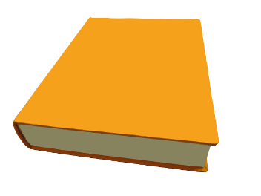
We have a special yellow folder with lots of pages to show what we can do, and all about us. This is kept safe in the office at Kiplings but we can look at this with our Key Workers. We have many pages to show what we can do and the achievements we have made.


If we have medication we have a special red folder too which is kept in the medical duty room, and this tells the grownups all about the medicine we take. This is very important and we can look at this too. The grownups use this to write when we have had medication if we need it.

Kiplings Routine
We come along to Kiplings from class and meet our friends from other classes too.
We have a greeting and say hello, talk about our day and what we will be doing in the evening.
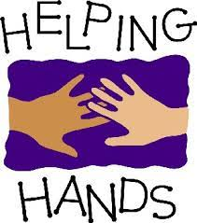
We all have responsibilities and little tasks called ‘Helping Hands’, which everyone enjoys.

Teatime
We go through to the dining room practicing our transferring skills. We practice our sitting, and sing our mealtime songs. Then we practice our eating skills. There is a menu that we help to put together with our ideas and choices.

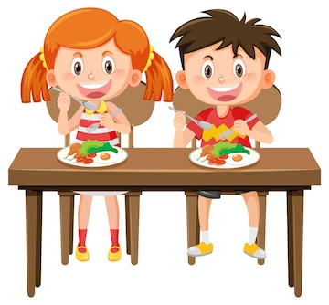
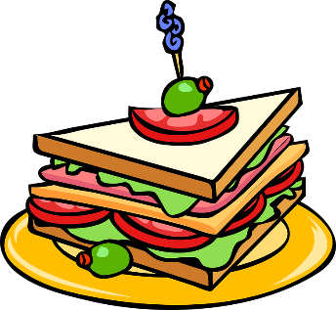


After tea, it is time for club activities and there is lots to do:
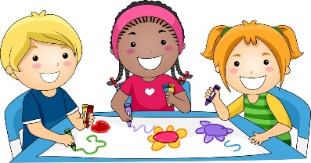
Art and crafts
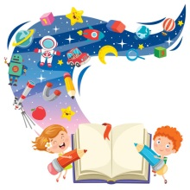
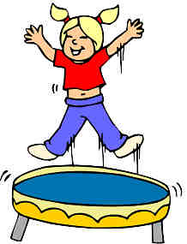
Movement and music
Sensory room
Gardening
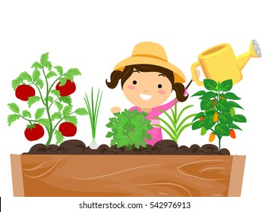
Rebound therapy

Story time and drama
Party nights
Homework

We are all involved in the “Horton EARS” School Council and have representatives who stay at Kiplings and share our ideas and thoughts.
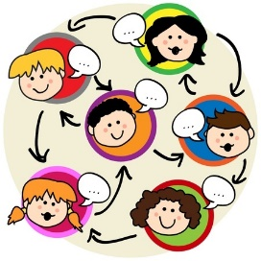

We are all involved in choosing our club activities.
After our club time we have free play and get to choose what we want to play with from all the toys. Sometimes it is nice to relax and have some quiet time, listen to music or a story, or watch a movie.

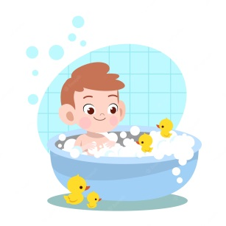
Bath Time
It’s time to choose a bath or shower and work on our independence - undressing, washing and brushing our teeth whilst enjoying time to ourselves.


Medication

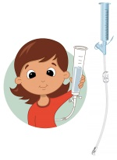
Some of the children have medicine and feeds and the staff will help with this.

Supper Time
We can have hot chocolate, juice, milk or water and a biscuit.
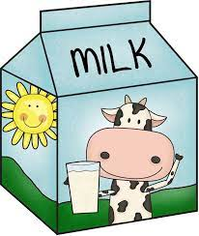




Star Time
Getting ready and saying goodnight to all our friends, we sing our goodnight song and share the star

Bed Time
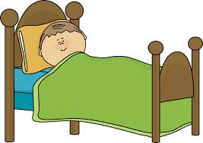
We get ready to get into bed, and have a story or there is time to chat. We have our own bed with a cupboard to keep all our things safe in. We can decorate our bed board with our favourite things that remind us of home and make us feel happy.

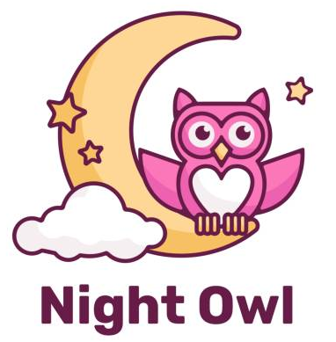

Tracey our night attendant arrives and always comes to say hello and checks that we are warm enough and comfortable.
We have a little monitor in the bedroom if needed to help to keep us safe and our Mums and Dads are happy with this.
Two staff leave to go home and two stay to sleep over in the staff area at the bottom of the corridor. If we need anything, they are always there to help. Tracey has a special button to press if we need help.

We have a Feelings Monster in Kiplings who helps us with our worries. We have chosen to call him Rainbow. Our friend Kathryn came to school and bought Bob the worry monster along with Rainbow for us to keep. We can talk to grownups if we are upset or worried and they will listen and help us.

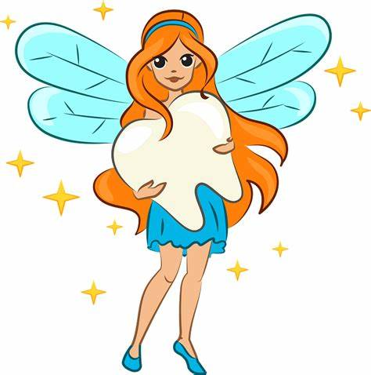
We also have Tinkerbell the tooth fairy that takes care of us if we lose a tooth until we get home.

Good Morning Routine
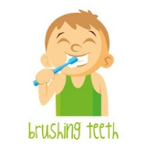

We wake up and the staff encourage and help us to get ready for school. We practice using different skills like getting out of bed, washing, brushing our teeth and getting dressed for school.

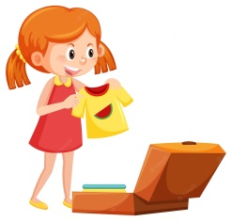
We help to organise and pack our cases taking all our important belongings home. If anyone needs morning medication, the staff do this now also.

Breakfast
We have our greeting, talk about the day and date, and organise our ‘helping hands’ before going through to the dining room.
Our friend Viji sometimes brings the breakfast in has a chat with us and sings our mealtime song with us, or the staff collect for us.

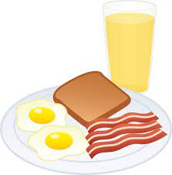
We think about how we are sitting and choose a prayer to sing or say, everyone is still and quiet, listening together.


Group Activity and Superstar Time
After breakfast there is time before class to do a group activity including sing up, stories or discussions.
We come together for our Superstar award and share each other’s achievements.

Time for Class
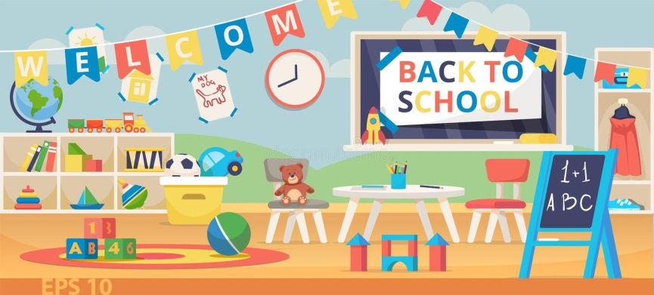
We prepare for class and say goodbye to everyone. Class staff come along to help us get to our class.

This is what it looks like in Kiplings:
The Dining Room The Playroom
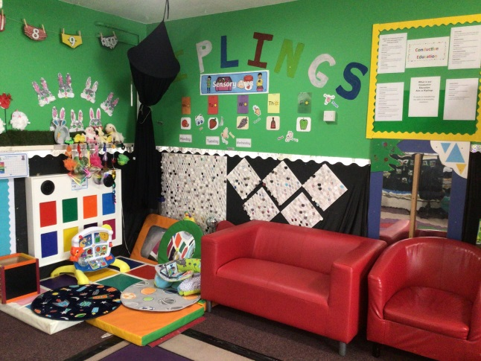
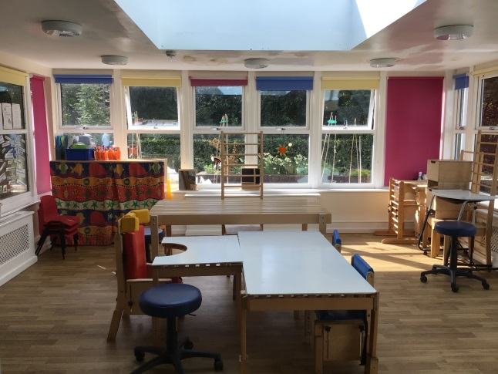

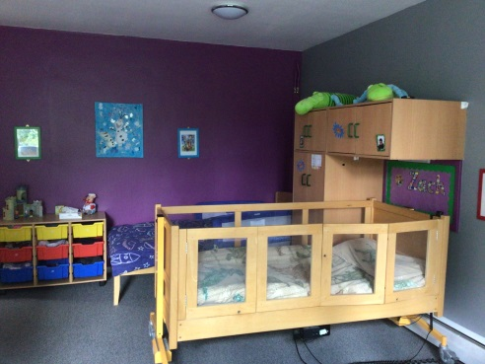
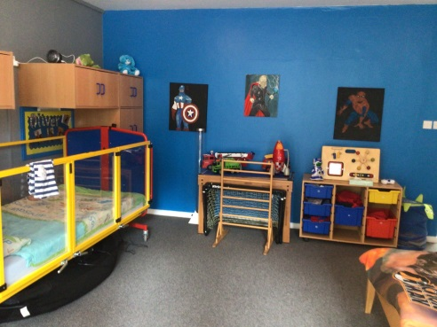
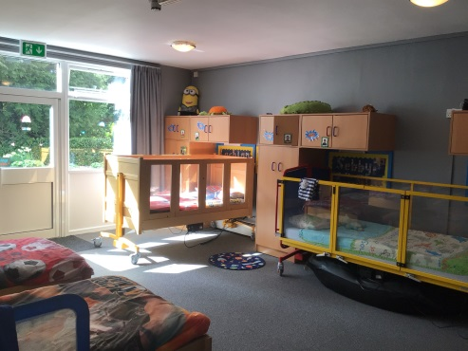
The Bedrooms

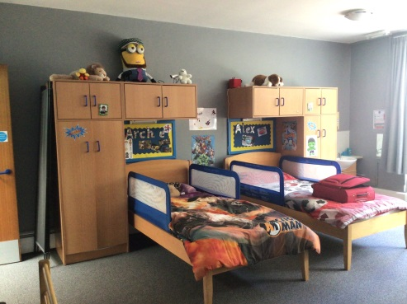
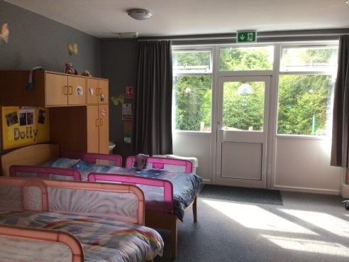
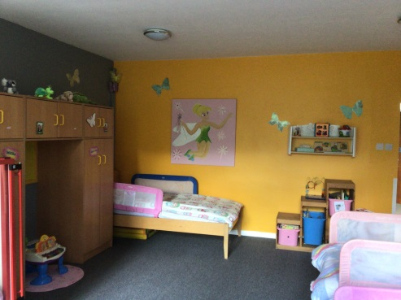
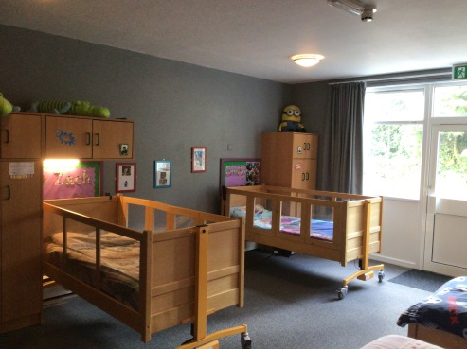
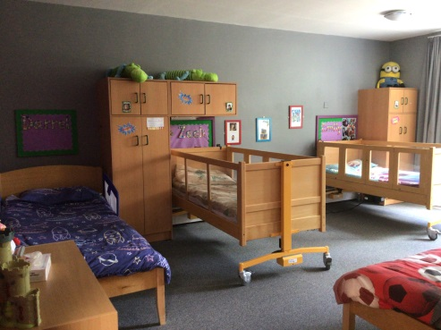

People who Work, Listen and Help Us in Kiplings

We have our Keyworkers in Kiplings and help from class staff too.

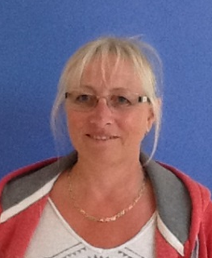
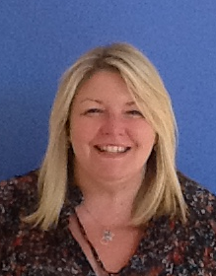
Julie Tracey Head of Care Night Attendant

Kate Carol Marie
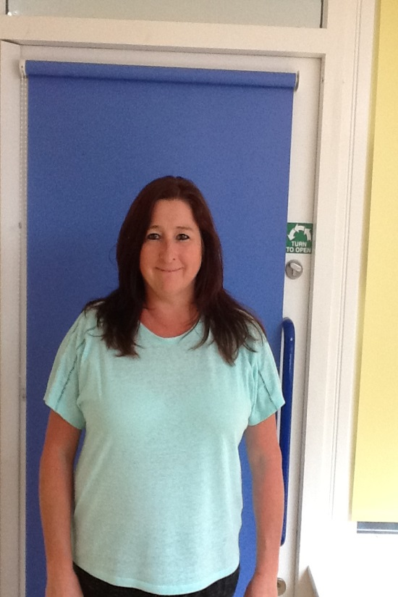
RSW/Keyworker RSW/Keyworker RSW/Keyworker
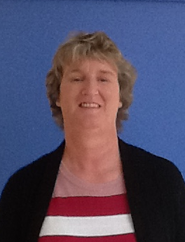
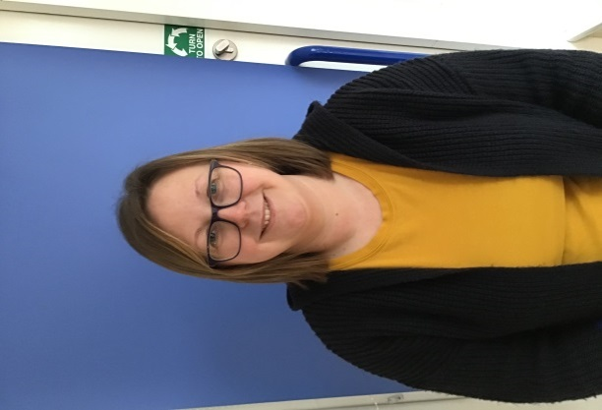

We can talk to the Safeguarding team Geraldine, Julie, Lucy, Abi and Sharon if we are worried about something or someone else and they can help.
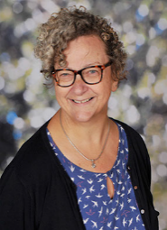
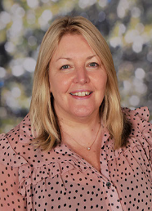

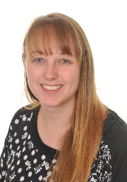
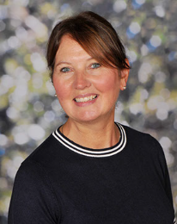

We can talk to Julie, Sharon, Heather, Jo, and Esta from the wellbeing team too.

People who Visit Us in Kiplings
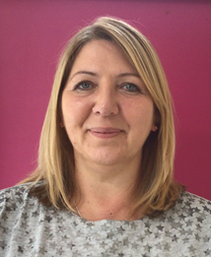
Tracey Carr Kirsty Burton
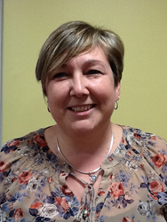


Both come along to see us and chat to us. We can talk to Tracey and Kirsty whenever we like.
We have Governors who come to visit us to see how hard we work.
They are called:-

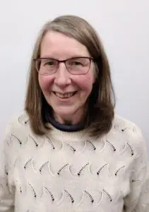
Michael Bedford Alison Lee

We also have a lady who comes to look at our work and how well we are doing. She looks around and makes sure that we have all the important things we need. She likes to stay and chat to us too. She is called:
Gill Venebals
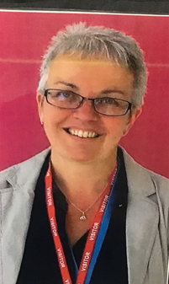


We have a visit from Ofsted each year, they help us to make sure that we are getting everything right to keep you safe whilst learning and having fun away from home.
Our last Ofsted visitors came to see us on the 11th, 12th and 13th of February 2024
They thought that we were outstanding in Kiplings.
What do we think and say about Kiplings?
I like certificates and working hard
I like the food at Kiplings
I like all the grownups that help me
I like playing with my friends
It’s the best
I like party time
I like the hot chocolate at bedtime
I like movement and music
I like the Superstars
I’m happy at Kiplings and know I’m safe
I can unpack and pack my case I like doing this by myself
I always feel happy and want to smile lots
I like my bed
I enjoy time sharing and listening to stories with my friends

I like taking the trolley back and doing jobs to help
I like chatting with the grownups and my friends
I like it when Tracey comes to say hello
I like doing things for myself now
I like my time to explore and by myself
I like talking and been listened to. I can sign and talk
I like everything
I like my bath time. I can splash and move in the bubbles
I like chatting to my mates at bedtime and laughing
I can practice self-propelling in my chair
I like bedtime stories with Marie

I like the bedtime star song
I love Sensory stories with Carol
I like sharing my news using my Podd book
We all like Superstar time and I like to clap and cheer
I like being involved with menu choices
I like helping hands and doing jobs
I like painting and sticking
I like having my safe space
I like to learn about new things
I like gardening and planting
I like choosing how to have my hair for school and going to Kate’s salon

