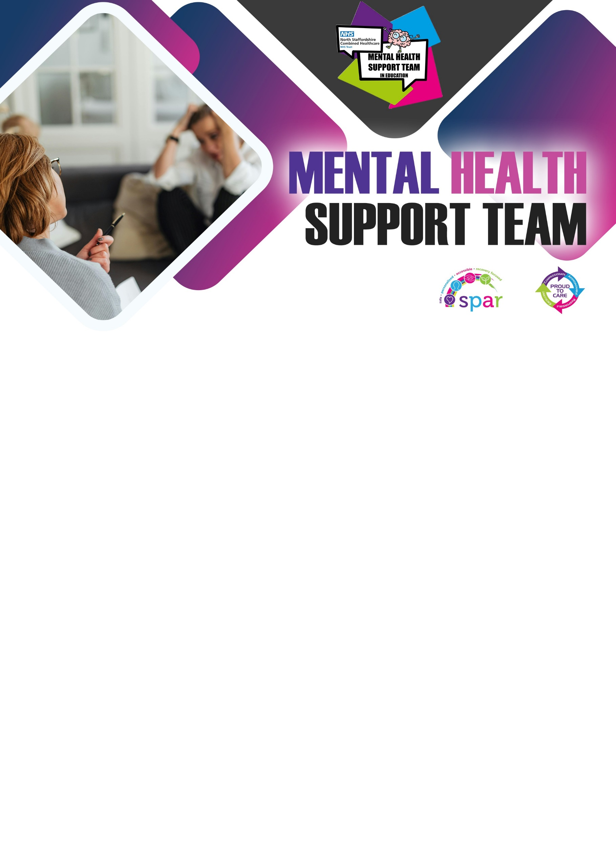
m

I support pupils with:
- Worry Management
- Anxiety
- Panic Management
- Low Mood
- Sleep
- Problem Solving
- Exam Stress
Education Mental Health Practitioner

All About Me

Hi, I’m Kathryn, from the Mental Health Support Team (MHST) working within Horton Lodge School.

I am an Education Mental Health Practitioner (EMHP) and my role involves supporting young people and their families with mild to moderate mental health challenges using Low Intensity Cognitive Behavioural Therapy (LICBT). Together we work to identify and address difficult emotions and feelings.

I work in partnership with the school’s Mental Health Lead to deliver a whole school approach to mental health; this includes educational workshops, groups, and training to reduce the stigma of mental health and improve outcomes for the whole school community.
Name: Kathryn
Our Core Offer

If you would like to know more, please speak to Julie Machin or email: mhstenquiries@combined.nhs.uk

